2021

Project Establishment

DEVELOPMENT OF THE BUSSINESS CASE

# ZENG XINYUE CHANG HUIRU

**Incentive(s) to create your project**

# Profit opportunity and a public demand

**About profit opportunity:**

# From the passage below:

<https://zhuanlan.zhihu.com/p/66037893>

Although this passage is not completely related to the product we create, the idea of this product can be used since we have the familiar service requirements. We can imitate its function and basic service.

There are 3 main profit opportunity：

## Technical Push Service:

They add the function of push in the right time, the right place, the right scene, push the right content to the right people.

## Use Mobile Internet marketing services to make money:

They add advertisements to create profits, which is a popular way for new product.

## Other technical Service:

We may add more detailed suggestions or contact to the experts in this field. However, this service may not be dependable to customers until we get enough good comments.

For example: provide platform for contacting.

**Public Demand:**

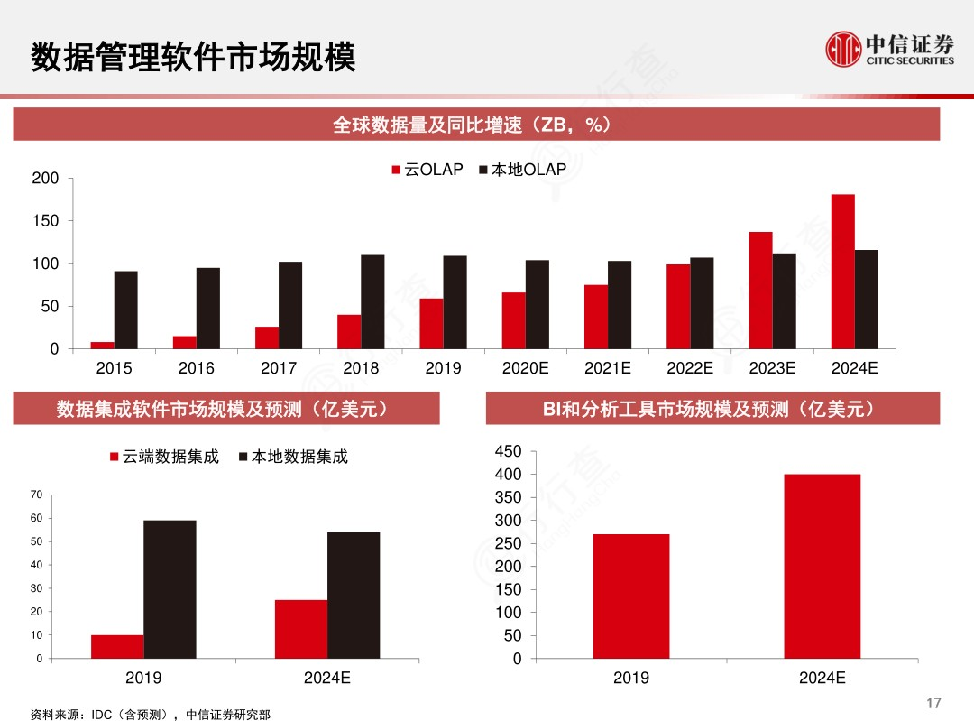

From this slide above, we can see that the

use of BI and analysis product will increase from 2019-2024

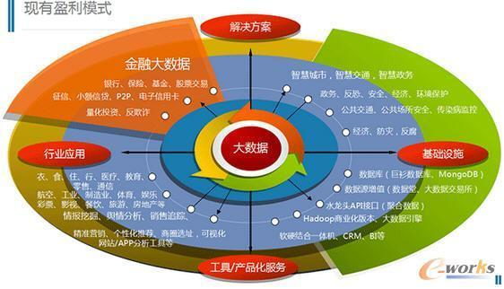

From the graph above, finance analysis is a big part of the big data.

**The brief project abstract**

1. short summary of the project:

Through the preliminary analysis of enterprise data, this paper provides a platform for SMEs to judge and suggest the possibility of credit.

1. Motivation(business justification)

We can see from the public demand that the market are really in need of the financing analysis, while the small and middle-sized enterprises don’t have data analyst to solve the problem. And big companies own their data analyst and government give it to the big company like three major credit reference agencies in the United States.

1. Challenges

Now many banks use the strategy: “one policy for one company”. It is because the companies and banks are at high risks while financing. Therefore, banks are extermely cautious. It may be hard for us to think of the data sources.

1. Major tasks envisioned
2. We will collect the data (economic strength, credit) related to enterprise financing. Those information is then given to the bank. Through algorithm and analysis, we will return the most likely successful scheme is returned.
3. Provide platform for communication between enterprises and banks.

We will ensure the safety of the privacy and transaction

1. Provide some professional advice and decision from experts.

5.Final Deliverables

An accurate, professional and personalized data platform

It's a product with security, one that banks and enterprises can communicate with each other easily